HYPERI~XTI~~NSION ORTHOSIS (.JEWITT)
The Jewitt brace is designed to prevent !lex ion of the thoracic & I,umbar spin.^{e}.
TOP

FRONT VIEW

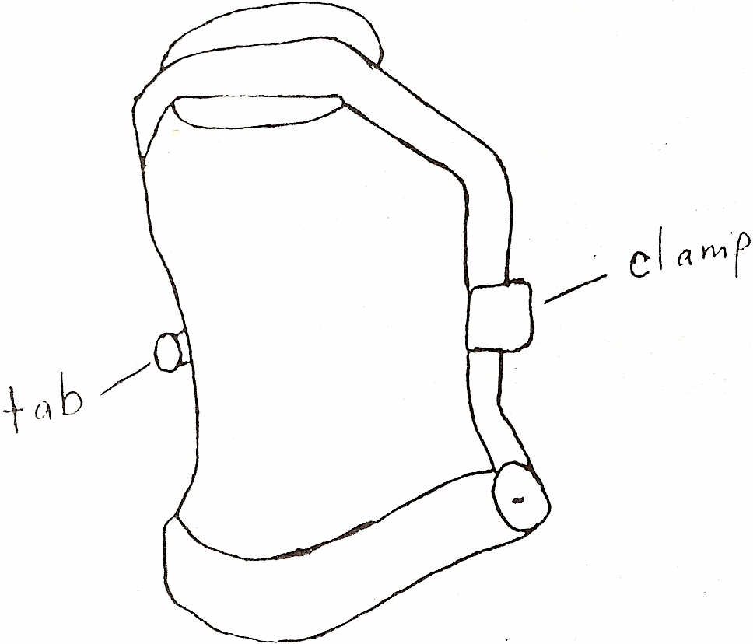

BOTTOM
How to apply: (in lying)
Ideally the orthosis should be worn on top of a '['-shirt. Lie on the bed & roll onto the right side.
Put the back pad & strap behind the back and slide the plastic tab under the right side.
Roll onto your back and bring the front section into place over the stomach and chest. To fasten the brace
- Right side -- Pull the loop of the plastic tab forward and glidc the round scrcw
head into the slot
- Left side - Push clamp backwards until it locks into position
The brace should feel tight.
For a proper fit the upper pad should rest on the sternum and the lower bar should .iust
touch the thigh when sitting.
If the sternal pad can be pulled more than 1 em away from the sternum then the brace
should be tightened.
Tighten the brace by shortening the back strap on the side of the plastic tab (right side).
How to remove: (in lying)
Left side - Pull the clamp forward.
Right side - Pull loop of plastic tab forward to remove round screw head from slot.
Roll onto the right side and pull plastic tab out from under the right side.
Take off brace.

When to wear brace:
The brace should be worn when sitting lip or standing.
It can be taken off when lying Ilat.
It should be applied and taken o!T in a lying position.
ShowerlBathing:
The brace can be worn in the water. 1\lh:r a showcr or bath remove the brace, towcl dry
and let air dry for a short time ( 1)- ~() minutcs)-
Care & Cleaning:
Use soap and water and a scrub brllsh or wash cloth. Altcr cleaning, towel dry and let
stand for a short time (15-~() minutes).
If you have any problems or concerns regarding the hrace please give AMPOS Orthopaedics a call at the following numher (613) 745-3173 or 1-800-216-6777.

