How to don your Below Knee shrinker sock

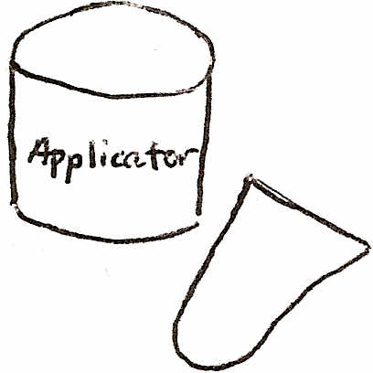
You have a stump shrinker and an applicator.

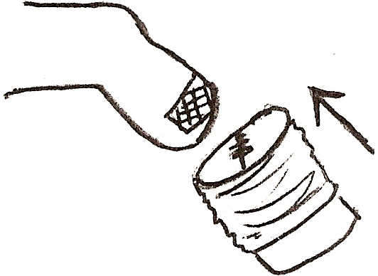
Align the shrinker so that the seam is left to right (so that it doesn't irritate the incision area). Push the applicator onto the stump, letting
the shrinker slide onto the leg.

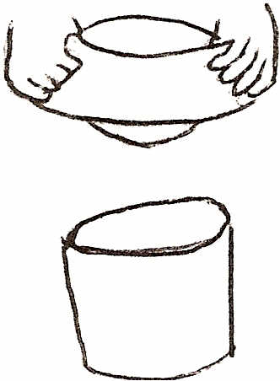
Invert stump shrinker over applicator. If this is difficult, you can use rubber gloves for grip.

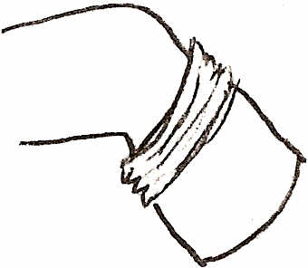
Stop when it can go up no further. Pull the sock off of the applicator and then pull onto the rest of the leg.

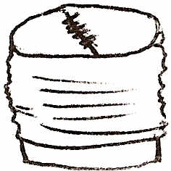
Get the shrinker on the applicator so that the top is as flat as possible - NO WRINKLES!

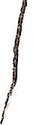
The shrinker should lay flat, with no wrinkles at the bottom. If the top of the sock tends to roll, fold the top over by 1-2".

You should wear this shrinker day and night. It should be washed regularly, especially if it gets soiled.
If you have any questions, Don't hesitate to call AMPOS ORTHOPAEDICS INC. (613) 745-3173

Instructions for a Donning a Trans-femoral Stump Shrinker

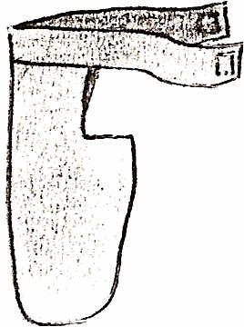

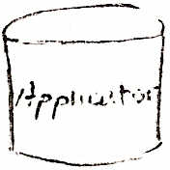
You have a stump shrinker and an applicator.
The stump shrinker has a belt. It also has an open area, which is to give room for the groin so the shrinker doesn't have to be removed to use the washroom.

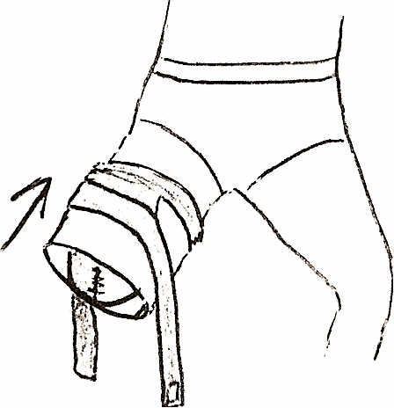
Align the shrinker with the seam pointing up and down so that when it is put on, contact with the incision area is limited. Push the applicator onto the stump, letting the shrinker slide onto the leg.
Stop pushing when the applicator has let the entire shrinker slide onto the leg. Remove applicator. If the applicator cannot be pushed onto the thigh any farther, pull the shrinker off of the applicator at this point and pull the shrinker up onto the rest of the leg. Attach the belt around the hips.

Invert the stump shrinker over the applicator. If this is difficult, you can use rubber gloves for grip.
Get the shrinker on the applicator so that the end of the shrinker is as tight and flat as possible on the top:
It is important to have NO WRINKLES.

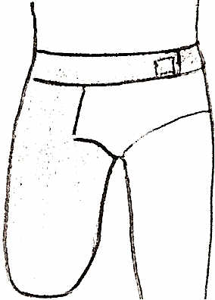
J
The shrinker should lay flat, with no wrinkles, especially at the bottom. The top of the shrinker should cover the entire thigh. No skin should be sticking out, especially around the groin. The seam should sit in a direction pointing forward and backward. Usually, underwear goes on over the shrinker.

If you have any questions, please call our Prosthetic/Orthotic facility:
AMPOS Orthopaedics Inc.
631 Montreal Road, Ottawa, ON (613) 745-3173 or 1(800) 216-6777
We also have a satellite office in West Ottawa at 3029 Carling Avenue, (613) 820-5950.

