Don Joy Lumbo-Sacral-Orthosis (LSO)

The Don Joy LSO is comprised of three separate pieces which are attached to one another: A) the back panel, B) the front panel, and C) the compressive belt with a pull handle (see fig. 1).
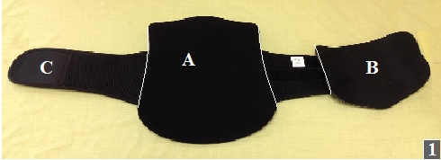

Intended use/indications: Acute and chronic low back pain, post-operative support, activity related low back pain, and disc herniation.

Warnings and precautions: If you experience any pain, swelling, sensation changes, any unusual reaction while using this product, consult your medical professional. If any fraying or deterioration of the cording is noticed, contact your orthotist and discontinue use.

How to apply: (in flat lying)
- On the orthosis, position and fasten the pull-handles as close as possible to the compression panels and fully extend the cord (fig. 1).
- Ideally the orthosis should be worn on top of a T-shirt, nightshirt, or long undershirt to allow for ventilation.
- Log roll the patient to their preferred side.
- Making sure that the inside label is at the top, tuck the orthosis under the patient’s side. Roll patient flat onto their back, making sure that the shoulders and hips are square. At this point, the orthosis may need to be pulled so that the orthosis is lying centered on the back. Feel the sides to make sure that the orthosis comes up equally on either side of the body. Never lift the hips AT ANY TIME. For proper fit and compression, center the spine between the two side panels and position symmetrically on waist (fig. 2 –NOTE rigid back panel has been removed from the pictures for clarity).
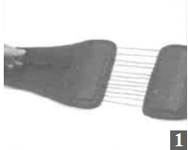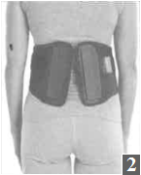
- Position the orthosis around the waist and fasten. The pull-handle will be on the left side. The soft lining will be against the body (fig. 3a and fig. 3b).
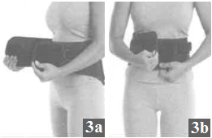

- To apply compression, grasp the pull-handle and pull to the right. After the desired level of compression is achieved (it should be very tight, but you should still be able to breathe), fasten the pull-handle to the contact strip on the side of the panel (fig. 4a, 4b, and 4c).
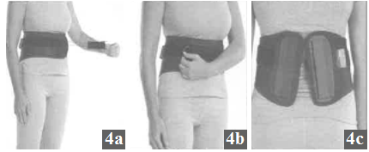

How to remove: Lie down flat on the back. Undo the pull handle all the way back, then undo the velcro straps. Log roll patient to most comfortable side. Slide out back section.
When to wear orthosis: The orthosis should be worn whenever the patient is sitting up or standing. It can be off when they lie down. It should be applied and taken off in a lying position. The Doctor’s activity orders take precedence over this instruction sheet.
Cleaning Instructions: Using mild soap, hand wash the orthosis in cold water. Allow it to air dry. Note: if not rinsed thoroughly, residual soap may cause irritation and deteriorate material.

If you have any problems, questions, or concerns regarding the orthosis please give AMPOS Orthopaedics a call at (613) 745-3173 or 1-800-216-6777.

