Bi-Valved Rigid TLSO (Clam shell) with Sternal Pad

The Clam Shell Orthosis is designed to restrict all motion of the mid and lower spine. The addition of the sternal pad acts as a high contact area to stop forward flexion.

How to apply: (in flat lying)
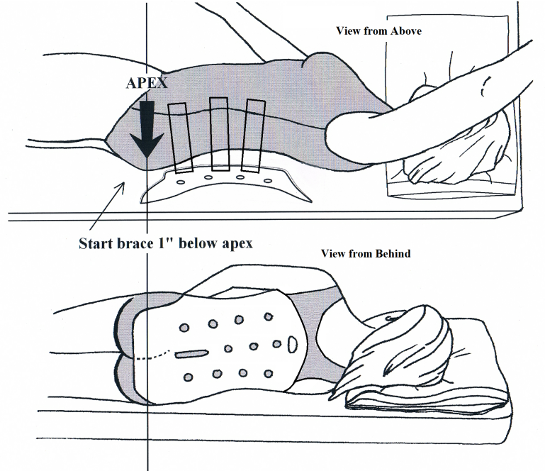
- Ideally the orthosis should be worn on top of a T-shirt, nightshirt, or long undershirt to allow for ventilation.
- Log roll the patient to their preferred side.
- Put on back section of the brace first, by sliding edge of brace and velcro straps under the patient's side. The bottom of the orthosis should be about one inch below the midpoint of the bum (so basically 2/3 of the bum is covered) and the mid-line of the orthosis should be slightly more toward the side that the patient is lying on (approximately 1" beyond the spine).
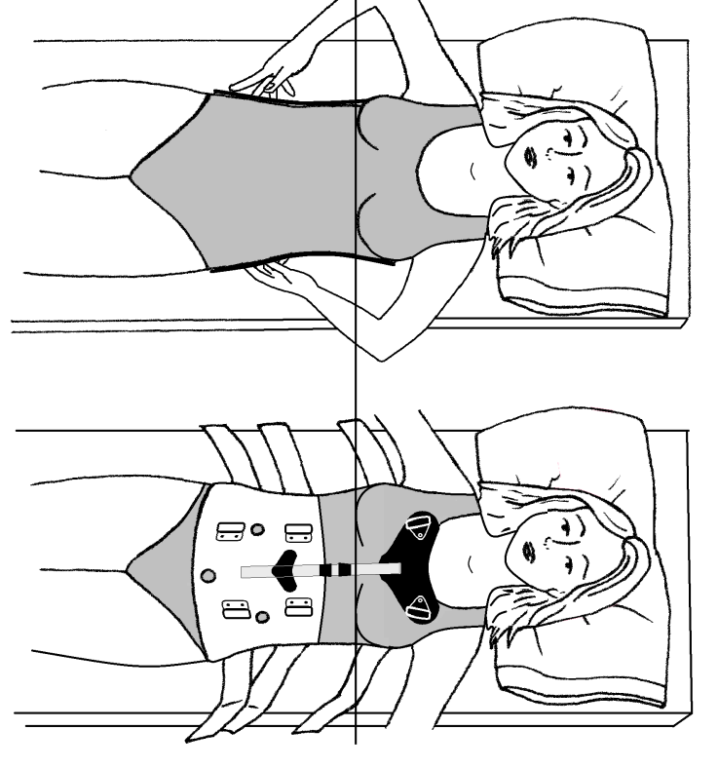
- Roll patient flat onto their back, making sure that the shoulders and hips are square. At this point, the orthosis may need to be pulled so that the orthosis is lying centered on the back. Feel the sides to make sure that the orthosis comes up equally on either side of the body. Never lift the hips AT ANY TIME.

- Next place the front section of the orthosis on the patient. This section should be placed low enough so that the belly is covered as much as possible. This may mean that the chest section is lower than normal, but it will move up once the brace is tightened. Straps should be done up from the bottom up, loosely at first, and then pulled tight. The bottom one should be very tight, the middle tight, and the top one snug. The wearer should be able to breathe normally, but NOT be able to take a deep breath through the belly.
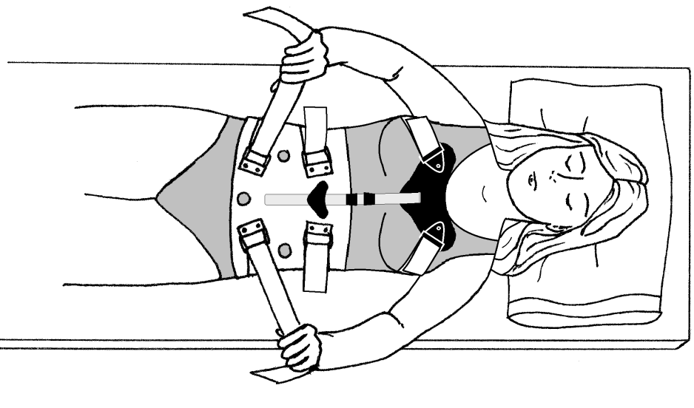

Turn the page over

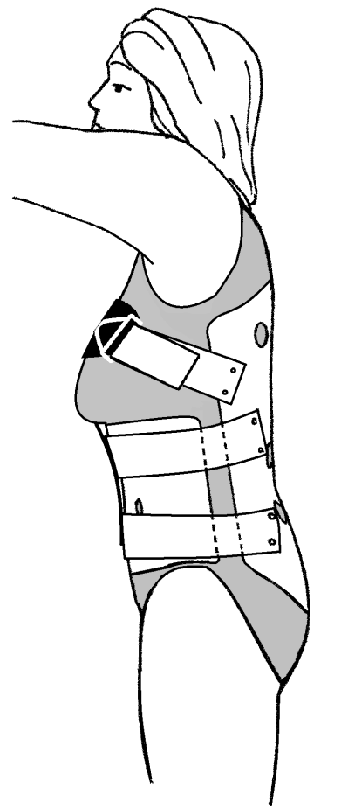
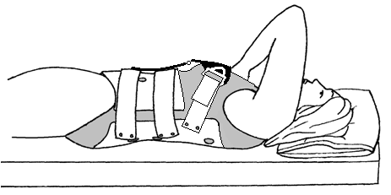
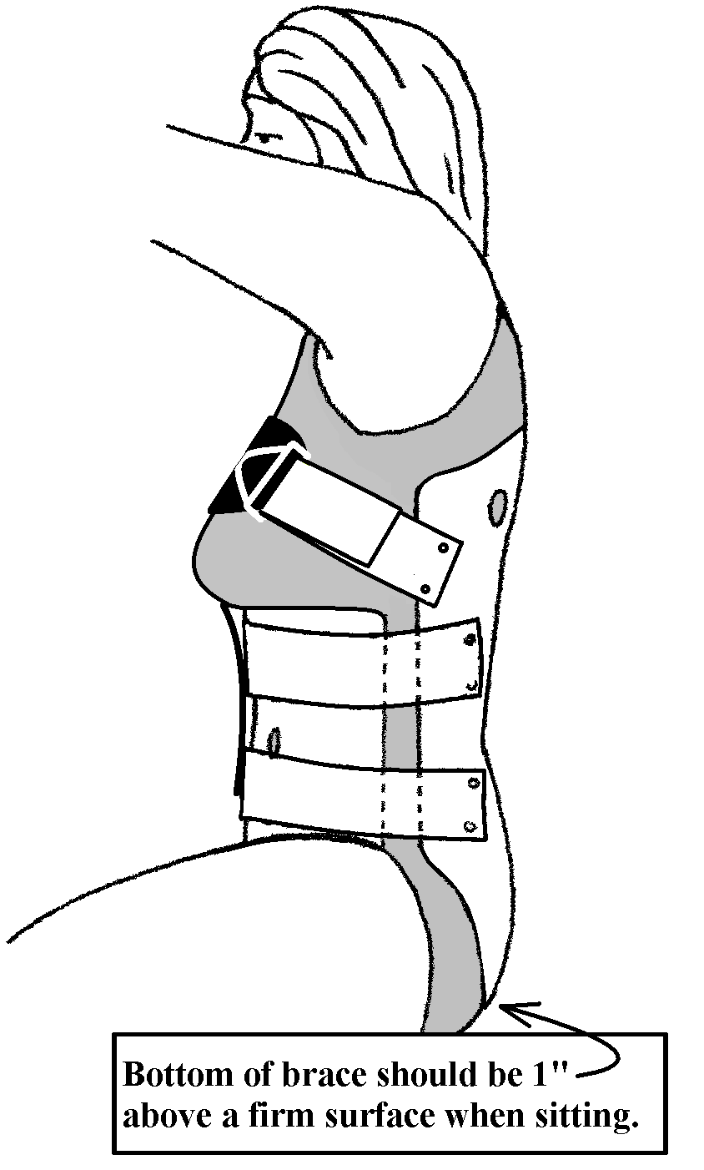
How it should look:

When wearing the brace in sitting, it should sit on top of the thighs, and the back of the brace should be about 1" above the seat of a firm chair. In standing, the back section should end at the height of the curve in the buttocks, and the midline should be within 1" of either side of the spine. If it is not there, it should be reapplied.
There needs to be a gap between the front and the back section. If these sections touch on both sides, the brace needs to be adjusted. Please call AMPOS to arrange to have this adjustment made.

How to remove: Lie down flat on the back. Undo velcro straps. Remove front section first. Log roll patient to most comfortable side. Slide out back section.

When to wear brace: The brace should be worn whenever the patient is sitting up or standing. It can be off when they lie down. It should be applied and taken off in a lying position.

Shower/Bathing: The brace can be worn in the water. After a shower or bath, remove the brace, towel dry and let air dry for a short time (15- 30 minutes). We usually recommend washing at night, so the brace can dry completely.

Care & Cleaning: We recommend washing at least once a week. Use soap and water and a washcloth or sponge. Rinse the soap residue off completely. After cleaning, towel dry and let stand for a short time (15- 30 minutes).

If you have any problems, questions, or concerns regarding the brace please give AMPOS Orthopaedics a call at (613) 745-3173 or 1-800-216-6777. To see an instructional video on how to don the brace, go to: http://youtube and search using the words “AMPOS” and “TLSO”, and you will see the video.

