Lumbar Sacral Orthosis (LSO)
The Lumbar Sacral Orthosis is designed to restrict motion of the lower spine as well as increase intra-abdominal pressure.

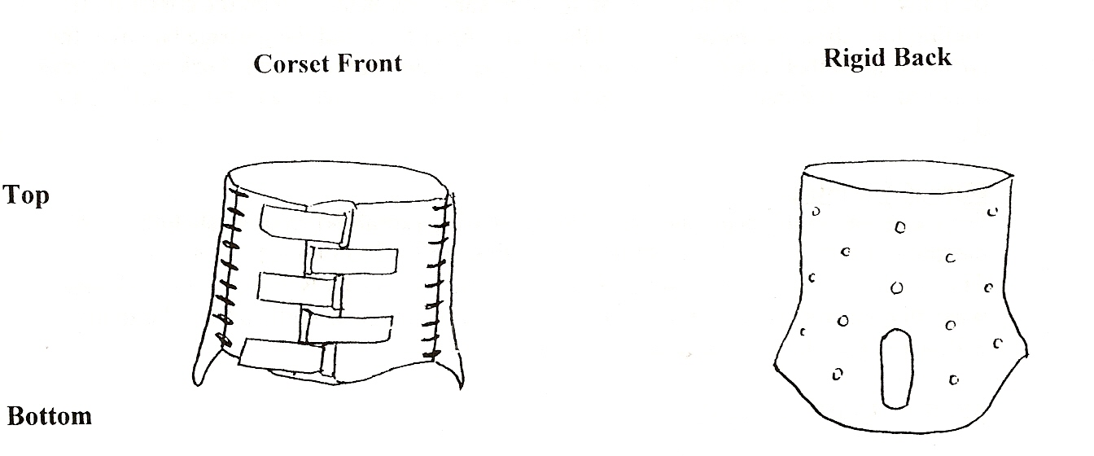

How to apply: (in lying position)
-Ideally the orthosis should be worn on top of a T-shirt -Roll onto preferred side
-Position back section of the brace by sliding edge of brace and corset front under the patient's side.
-The bottom of the orthosis should be about 1” below the mid-point of the curve of the bum.
-Slide brace under the body, going 1" past the centerline of the body.
-Roll patient onto their back.
-Make sure that the orthosis comes up equally on either side of the body, if not, patient should roll over & brace pulled.
-Never lift the hips!
-Patient should be centered on the back section of the orthosis.
-Do up all of the front straps, starting at the bottom, then go back and re-tighten each strap. -You should be able to breathe normally but feel the brace restrict you from taking a deep belly breath.
In a sitting position check that the orthosis is aligned well, front and back. From the front, the bottom of the cotton corset should just touch the upper thigh and the top of it should be just below the sternum. At the back, the bottom of the orthosis should be about 1" above the seat of a hard chair. The centerline of the back of the brace should be within 1" of the spine. If not, it should be repositioned.
How to remove: (in lying position) Undo Velcro straps.
Open the cotton corset section.
Log roll patient to most comfortable side.
Pull the brace out to remove.

When to wear orthosis:
The brace should be worn whenever the patient is sitting up or standing. It can be off when they lie flat. It should be put on and taken off in a lying position.

Shower/Bathing:
It is best to shower at night so that if the corset front gets wet, it will have time to dry. Remove T-shirt. Lying on your back, take a large garbage bag and lay it flat over your stomach. It should lie from the groin to up toward your head. Do up the corset front, folding the fabric extensions toward the front. After this, fold the garbage bag over the corset front so that it covers both the inside and outside of the cotton. Tuck the bag back under the front, especially on the sides. After a shower remove the orthosis, and let air dry.
Care & Cleaning:
For the foam lined plastic, use soap and water with a scrub brush or washcloth. After cleaning, towel dry and let stand for a short time. (15 - 30 minutes)
Try to wash the corset front at night, so it has time to dry. Unlace the corset and hand wash in cold water and a mild soap (no fabric softener), rinse well and lay flat to dry. Re-lace in the same position as it was before.
Special Instructions/notes:
Patient Name:
Type of Orthosis: _
Patient Cost: $
---------------
Prescribed by: _
Orthotist/ Supplier: Christopher Kraft, RTPO, CPO(c) AMPOS Orthopaedics
631 Montreal Road
Ottawa ON, K1K OT4
(613) 745-3173
1-800-216-6777
If you have any problems or concerns regarding the brace, please call AMPOS Orthopaedics at (613) 745-3173 or 1-800-216-6777.

