Corset Instructions

The corset can be put on in standing, sitting, or laying, depending on the injury. If it is post-surgery, it is put on lying down.

If sitting or standing, pull the corset around the body and attach. Some corsets have hook and eye closures, snaps, or Velcro.

Make sure that the corset is in the right place. The fabric tag is typically on the top edge of the brace. It needs to sit low (ending at the roundest part of the backside). It should have the stiffest metal stays sitting on either side of the spine. The laces should be evenly on the sides, as pictured.

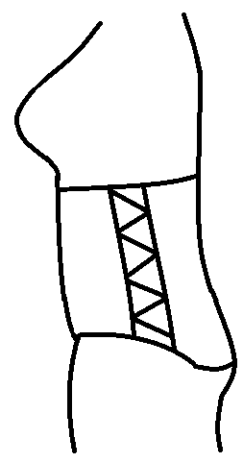 | 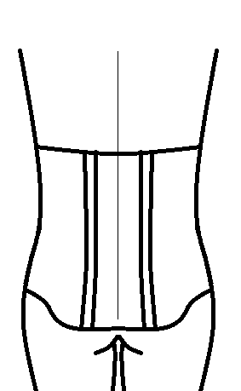 | 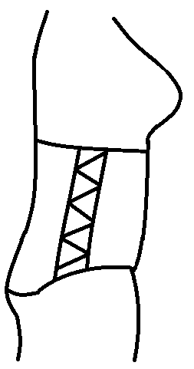 | 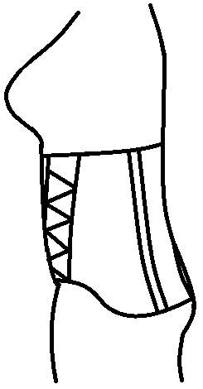 | 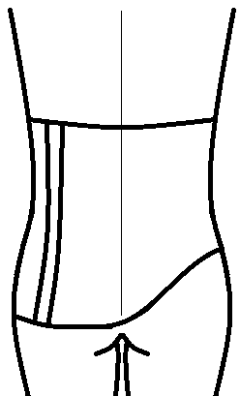 | 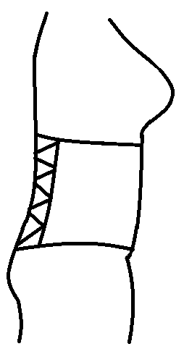
Left side | Back view | Right side | Left side | Back View | Right side
Correct placement |  |  | Incorrect placement. This corset is  turned too far to the left.

If the corset is not sitting properly, it should be turned, unfastening if necessary, until it is correct.

The corset now needs to be tightened. The best position for this is lying on the back. Ensure that the corset goes fully over the tummy, pulling down on the corset and up on the tummy. This stops the corset from pinching into the tummy when sitting, and from sliding up into the chest.

Tummy still showing below the corset | Pull down on corset
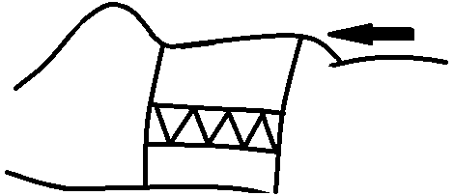 | 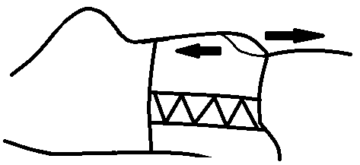
 | Pull UP on belly

Starting on the bottom, tighten the side straps, either pulling them both straight out to the side, or both forward. Fold over across the front. Repeat with the top straps. You want the bottom strap to be the tightest, which forms a wedge. If not, the corset will tend to slide up.
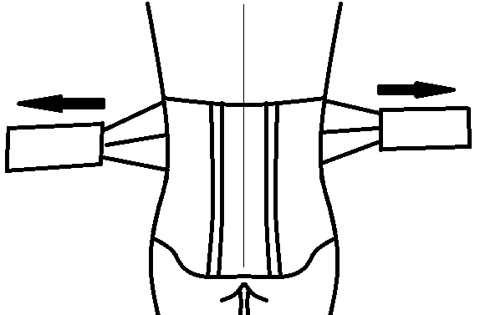 | 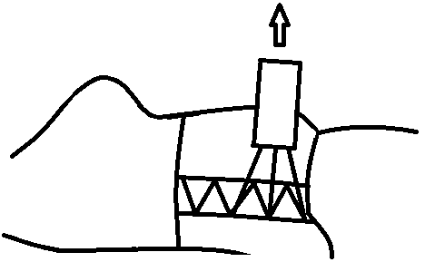 | 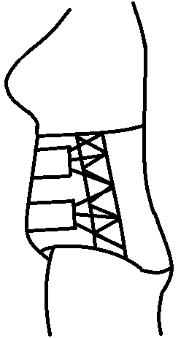 | 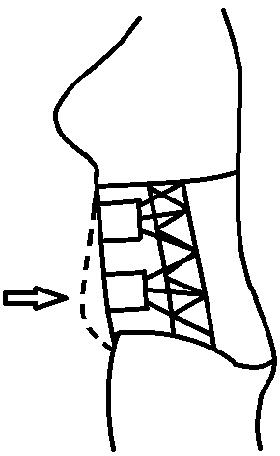
Pull outward | Pull upward | Too loose | Best position

The corset should be tight. You should be able to breathe normally, but not take a deep belly breath.

If you have any questions, please call Ampos Orthopaedics at (613)745-3173.

