Ampos Orthopaedics Inc.
631 Montreal Road, Ottawa, Ontario, K1K 0T4 Tel: (613)745-3173 Fax: (613)745-6937
Patient Instructions for the Newport Hip Abduction Orthosis
Your hip orthosis consists of a pelvic band that goes around your waist, a thigh portion that wraps around the thigh on your affected side, and a hinge that holds the two pieces together and regulates the range of motion. This hip orthosis has been prescribed to keep your hip within a safe range, to prevent dislocation and to promote healing.
It is helpful to wear a T-shirt under the orthosis, but the rest of your clothing including underpants should be worn on top of the brace. Sweatpants and other pants with an elastic waist work well.
The hip brace should be applied while lying in bed to best protect your hip. At first, you may need help to get it on and off, but many people are able to do this independently after a week or so. The orthosis is designed to keep your leg out to the side and to keep you from flexing too far forward. It is designed this way because patients most often dislocate in a seated position when they are leaning forward more than 90 degrees with their problem knee and hip turned in. In this position, the hip prosthesis has the least amount of coverage in the socket, and it can slip out of the back of the pelvis. To prevent this, the orthosis abducts or turns the leg out so that the hip gets the most coverage within the hip socket and stays in place.
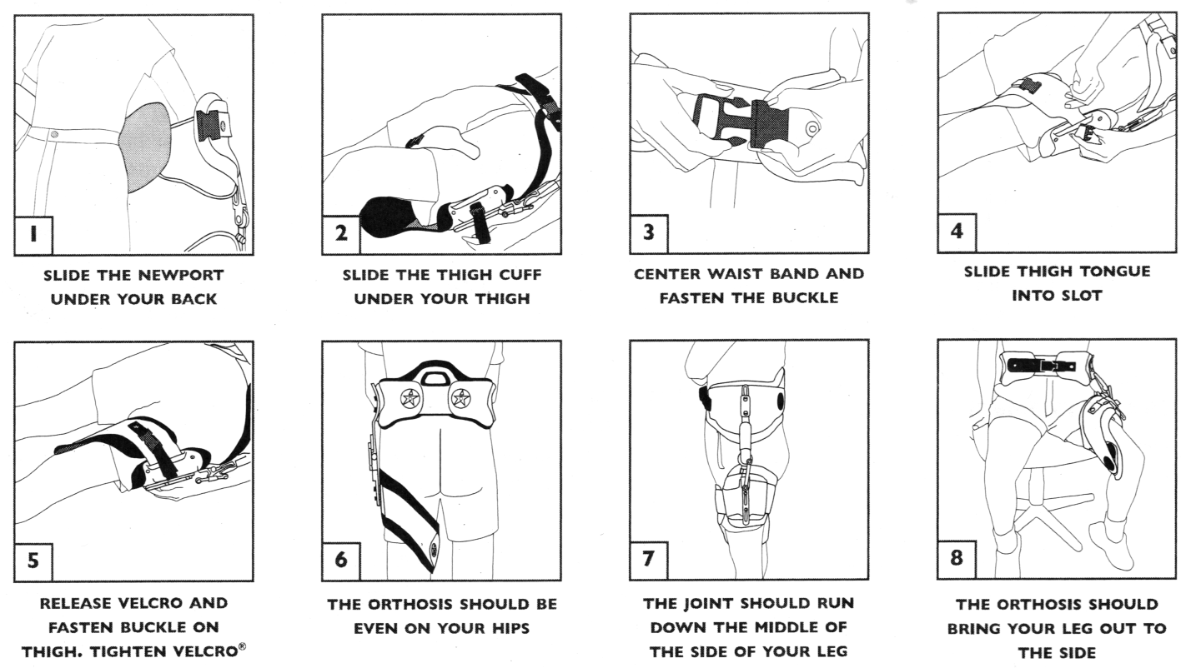
Follow your Dr.’s orders for brace wear. Contact your orthotist if you have any specific problems with the brace by calling AMPOS Orthopedics at (613) 745-3173. The orthosis fit is warranted for 3 months, and the materials are warranted for one year.
Cleaning Instructions: Remove the foam pads by pulling them away from the Velcro hook material on the inside of the orthosis. Wash the pads in warm, soapy water. Rinse well to remove soap residue. Allow pads to air dry. Replace pads.
Cost: $1025.00 (effective Jan. 2017)
BRACE REQUIREMENTS ORDER FORM
Date: __________________________________________________________________
Signature: ______________________________________________________________

WEIGHT BEARING
STATUS
With Brace | □ | WBAT
With Brace | □ | PWB
With Brace | □ | TTWB
With Brace | □ | NWB
Without Brace | □ | WBAT
Without Brace | □ | PWB
Without Brace | □ | TTWB
Without Brace | □ | NWB

ROM
Hip Flexion | __________˚
Hip Extension | __________˚
Hip Abduction | __________˚

BRACE WEARING SCHEDULE
Supine | □ | YES
Supine | □ | NO
Sitting | □ | YES
Sitting | □ | NO
Standing | □ | YES
Standing | □ | NO
Night | □ | YES
Night | □ | NO

